ḤAJJ PROJECT – Resources
3D Models
Paper Mache Ka’ba
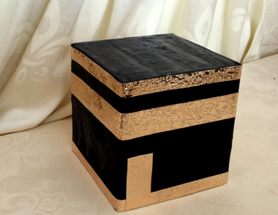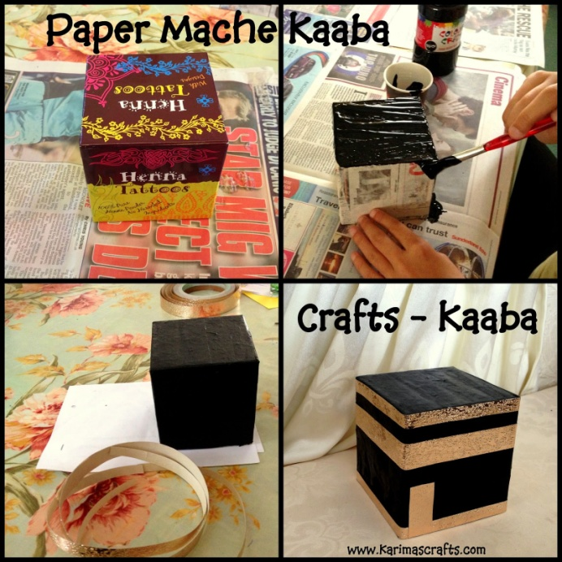
This Ka’ba is made using a square box, some gold tape and paper mache! It can also be made in several different types of way, not just paper mache.
- Requirements:
- Square box (rectangle or a cut down shaped one will do!)
- Black Paint (or black paper to cover)
- Gold Tape (or gold paint)
- Newspaper and Paper Mache Paste (I used flour and water for paste)
- Glue if needed

- Instructions:
- Prepare Paper Mache Paste and cut out strips of newspaper.
- Cover the box in the paper mache and then allow to dry.
- Using Black Paint cover all the visible sides in black paint and allow to dry.
- Using Gold Tape, place strips around the Kaaba for decoration and a small strip for the door. Alternatively you could use Gold Paint.
Helpful Hints:
Using Paper mache means waiting for this to dry so if it is possible you could paint the box directly. There are many online recipes for paper mache or use wallpaper paste. You could also use black paper to cover the sides of the box and glue securely. If you don't have a box you could just cut a large box down to the size you require.
Maqame Ibrahim (Group Exercise)
- Requirements:
- A large piece of white card
- Gold crepe paper
- Gold glitter
- Black marker
- Two little feet!
- Scissors
- Glue

- Instructions:
- Draw out the image as per the picture below (sorry, no template for this size!).
- Draw around two (clean!) feet, and then colour in with a black marker.
- Cut the crepe paper into squares and glue on.
- Apply the glue and gold glitter on the strips as per below.
- Label and hang up on the wall!
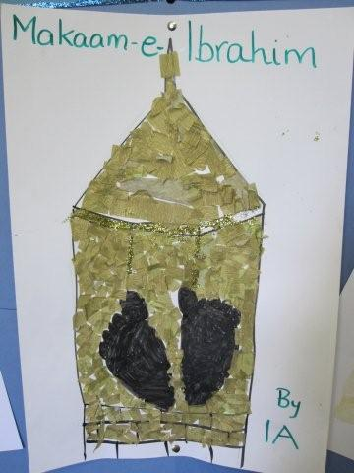
Make a Large Ka’ba
- Requirements:
- Box
- Bronze paint
- Black marker
- Black felt
- White cardboard
- White foam
- Foil
- Golden trim
- Jewel stone stickers
- Black pebble
- Ka’ba door photograph/model.

- Instructions:
1. Paint the bottom with bronze paint.
2. Then with the marker, draw bricks.
3. Cover the rest of the sides with black felt.
4. On the top, use white cardboard and on the sides, white foam (as bpic below).
5. Glue on a foil frame for Hajre Aswad, and stick on the black pebble in the middle.
6. Decorate as below with golden trim and jewel stone stickers.
7. Stick on the Kaaba door photo/model.

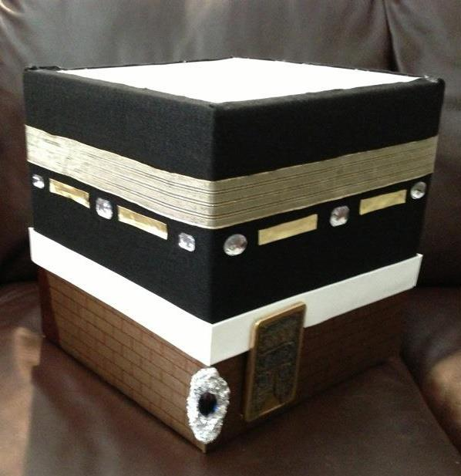
3D Ka’ba Model
- Requirements:
- 6 sheets of black card
- Gold crepe paper
- Sticky tape
- Glue
- Scissors
- Instructions:
1. Cut 5 black cards into square shapes (can be as big/small as you would like your model to be)
2. Tape them together to make a cube
3. Stick the cube onto the remaining black card
4. Decorate the Kaaba with gold crepe paper using tape or glue

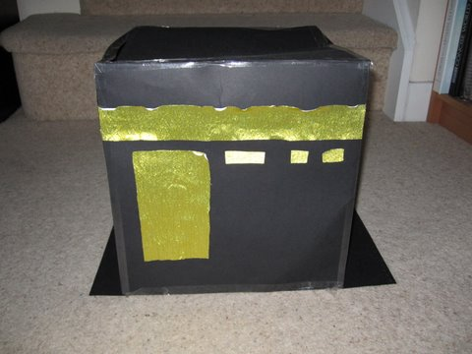
Diary Writing
- Put the date or some sequence information in the diary, maybe at the top of the page.
- If you want, you can put stickers on various pages or draw some doodles to express how you feel about something.
- Start writing! Write about how you feel and why you feel that way. You can write about any celebration or disaster that happened that day. Or you can write freely. Put your pen to the page and write whatever is on your mind. Write cool facts, important information, advice, tips, ideas, crafts, recipes, anything you want to keep secret...the list goes on and on.
- Start with the morning. Describe how it went and do not leave out any detail. If you wanted the day to go better, write how and why. Move on to the afternoon, then the evening and finally the night. Always say good night in the end and promise to tell more later.
- If you writing in a paragraph about the incidents happening in your life, then you can use a fancy bookmark (similar to your diary) to keep a record till where you have written and you can read back at your writings if you are writing after a few days.
- Always think that the diary is a real person and not a non-living creature.
- Close with your name. You can also add your signature. If you want to, end your entry with “Salams” or "Good night."
- You can also stick some souvenirs like photos, flower petals or anything associated with what happened that day to be more creative. You might even want to tape in your ticket and your visa!
- Sticking an envelope into your diary can be a great way to safely keep photos, tickets, postcards, etc.
- Try something of your own. For example, you can write at the end of every day "The lesson I have learned is that when life gives you lemons..." and write a different ending to the sentence every day. Be creative.
Board Game | Ḥajj Guide | Ḥajj Map
- We will give you information to find out more about the Ḥajj, its locations and its rites and rituals.
- Use your imagination for this one!
Ḥajj Website
- Create a free website with www.wix.com, www.weebly.com, or www.simplesite.com
Ḥajj Through History
Mansa Musa
- Youtube: Mansa Musa and Islam in Africa (https://www.youtube.com/watch?v=jvnU0v6hcUo)
Ibn Battuta
- Film: Journey to Mecca: In the Footsteps of Ibn Battuta (http://kalamullah.com/journey-to-mecca.html or http://islamicmultimedia.blogspot.co.uk/2013/10/journey-to-mecca-in-footsteps-of-ibn.html)
- Book: The Travels of Ibn Battuta (Translated by H.A.R. Gibb) (Focus on Chapter 1)
Ibn Jubayr
- Book: The Travels of Ibn Jubar (Translated by Roland Broadhurst) (Focus on pages 75 -212)
Lady Evelyn Cobbald
- Article: ‘Mayfair to Makkah’ (http://www.aramcoworld.com/issue/200805/mayfair.to.makkah.htm)
Sir Richard Burton
- Book: ‘To the Holy Shrines’ (By Sir Richard Burton)
Muḥammad Asad
- The Road to Mecca (by Muhammad Asad)
Malcolm X
- Autobiography of Malcolm X - (Focus on Chapters 17 and 18)
- -Interview with Malcolm X After Return from Mecca (1964) (https://www.youtube.com/watch?v=fdSXtnBqPBA)
-Malcolm X Returns from Mecca: Complete Press Conference (1964)
(https://www.youtube.com/watch?v=N0wnV0EsmqA)
-Malcolm X Letter from Mecca (Excerpt from Malcolm X Film)
(https://www.youtube.com/watch?v=K9bdYv8b--U)

