[www.hamidmahmood.co.uk](http://www.hamidmahmood.co.uk)

[hamid.mahmood@heythropcollege.ac.uk](mailto:hamid.mahmood@heythropcollege.ac.uk)

Cann Hall Madrasa

Going to Mosque





What is the **MOST** important thing for a Muslim?

**WHY?**

What is the **LEAST** important thing for a Muslim?

**WHY?**

**Respecting** others





Prayer

Charity

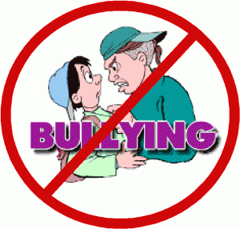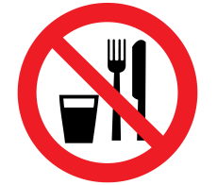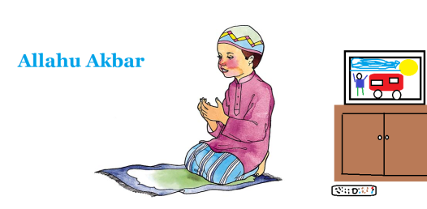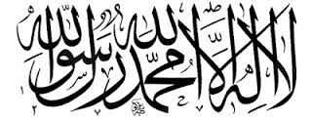

Hajj

Fasting - Ramadan

**Stopping** a Bully

Helping Others